DAGV 1700 Unit 2 Submission
- Screenshot #1: Unity Editor showing your Player in the Scene and the Inspector with Character Controller, SimpleCharacterController, and FlipTransformBehaviour components visible.
  - 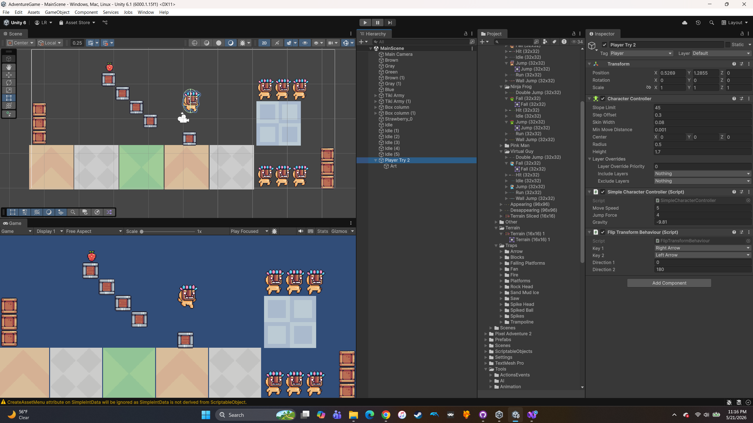
- Screenshot #2: GitHub Desktop window with your forked Essentials repo selected, showing the local path and at least two commits on different days.
  - 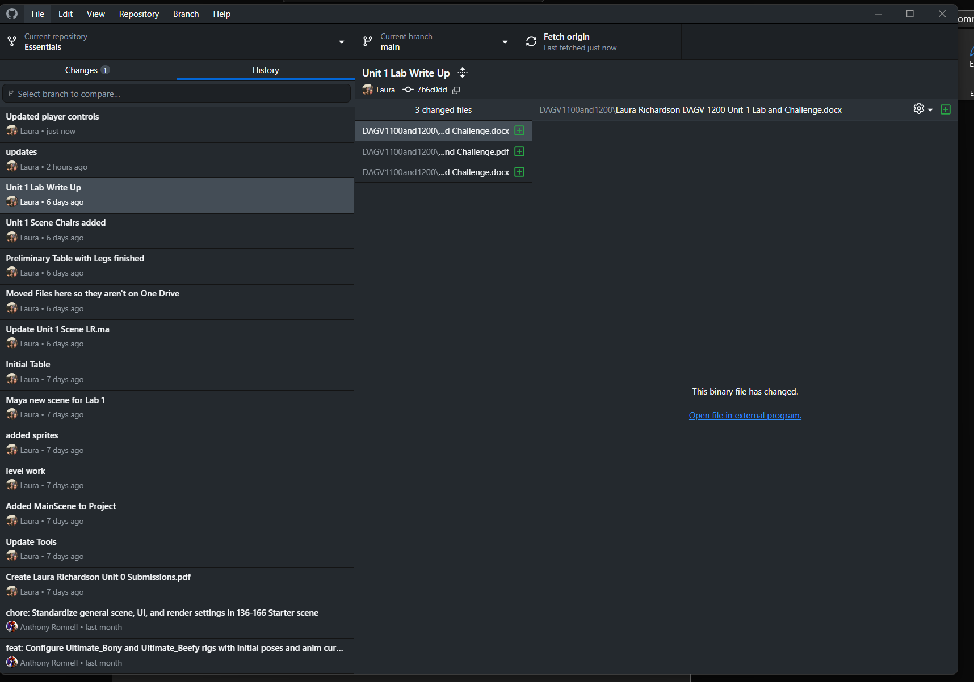
- 100-Word Write-Up:
  - I’m still struggling to get my player to work and collide with the box colliders. I set up an empty game object, renamed it a couple different things to see if that made the difference. I then added a character controller component, a simple character controller component, and a flip transform behavior component. After that I made a child for it and called it art and picked the sprit I liked. I still can’t figure out what is wrong. I redid my box colliders, and I redid all the components additions with the player. I did mess around with the simple character control size to make it look right. When I press play, the player just falls through all my platforms. I can make it move and jump, but it’s not working properly. I need help.
- Repository URL: https://github.com/richar65/Essentials

